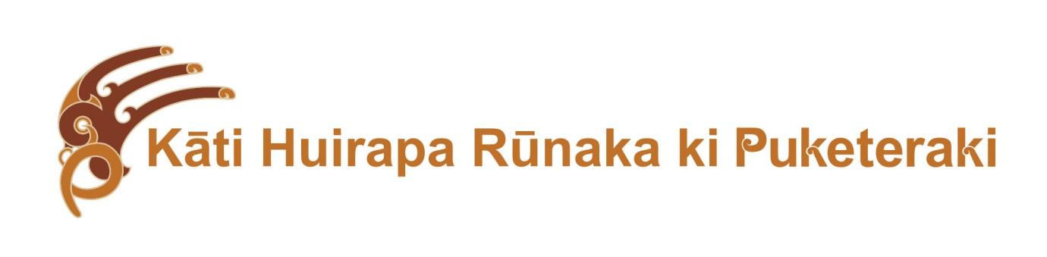
He Korowai KŌkiri; BUILDING LEADERSHIP CAPACITY

Purpose: The purpose of He Korowai Kōkiri is to build the capacity and capability of Kati Huirapa ki Puketeraki Runaka members in order to meet our future inter-generational aspirations. As such, grants have been established that will focus on increasing skills and knowledge of members who already take an active leadership role in areas that benefit the Runaka long-term. This includes rangatahi who have been identified as having leadership potential in particular areas that are within the strategic goals of the Runaka. The criterion for knowledge transmission must be adhered to, and recipients encouraged in a long-term leadership role.
Grants are capped at $1,000, with $5,000 in total available annually.
Areas for support include:
- Cultural leadership such as;
- Aoraki Bound or waka voyaging and training
- Rongoā Māori wānaka
- Weaving
- Te Reo Māori (leading to teaching/wānanga)
- Any other training approved by the He Korowai Whānau Committee

- Academic leadership such as;
- Marine or other environmental sciences
- Education
- Commerce and management
- Governance training – either Director or Trustee
- Archival history/taonga
- Any other training approved by the He Korowai Whānau Committee
Criteria/conditions: The funding will be allocated with the following expectations:
- The recipient has demonstrated leadership in Runaka activities or has leadership potential to contribute to the well-being of the Runaka:
- The recipient is currently actively involved in Runaka activities
- The recipient can contribute and enhance the knowledge base and skill base of the Runaka
- The recipient agrees to bring that knowledge back to the Runaka in some way that benefits Runaka membership e.g. run workshops.
- The recipient must be a registered member of Kāti Huirapa Runaka ki Puketeraki Inc. Soc.
The amount awarded to each recipient will be at the discretion of the He Korowai Whānau Committee and members who receive a grant will not be eligible to apply for another grant for 2 years.
He Korowai Whānau Komiti, May 2016

